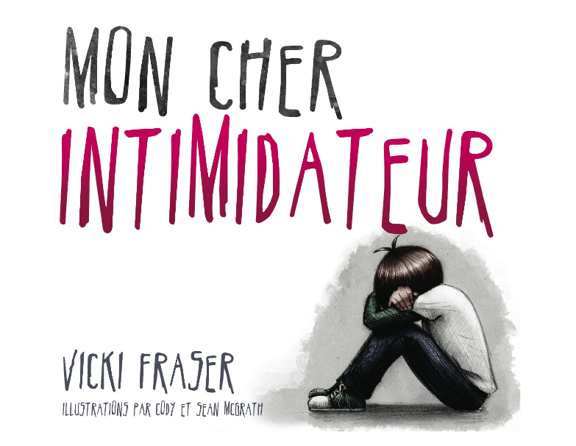
La semaine anti-intimidation aura lieu du 18 au 22 novembre. Nous voulons partager vos histoires sous forme de lettre à votre intimidateur aux annonces le matin, en toute confidentialité. Nous vous remercions pour votre partage.
L’empathie nous réunit.
Sincèrement,

________________________________________________________________________

